Boomerangs Minutes
Mayfield Boomerangs Baseball Club
Date | Time 9/1/2024 | 7:05 PM |Meeting called to order by Grant Harris (VP)

In Attendance
Attendees: Grant Harris (Vice President), Jake Bramble (Secretary), Josh Voigt (Assist. Secretary), Matthew Reeves (Treasurer), Joel Pettigrew (Assist. Treasurer), Chris Frank, Jane Frank, Ann Voigt, James Foster, John Mossop
Apologies: Megan Gleeson, Stephen Petherbridge, Virginia Petherbridge, Kerrie Metcalfe, Josh Neville, Jason Picot, Tanya Picot, Rob Voigt, Kerrie Metcalfe, Elaine Scotney

Approval of Previous Minutes

Moved: Grant Harris | Seconded: Josh Voigt

Business Arising from Previous Minutes
- Committee discussed alternative management platforms to address shortcomings of SLACK.
        - Attending members in favor for the use of Facebook Messenger for communication and a shared Google Drive for storage of important documents.

- Jake sought clarification regarding public liability expiry date when organising in-season ground application with council and Active Kids vouchers.
  - Expiry date of previous policy irrelevant, new policy will auto-renew.

- Jane reached out to her contact regarding attainment of club defibrillator.
  - Jane presented 2 quotes to committee. Motion to purchase defibrillator passed unanimously.
  - Jane to send invoice to Matt for payment.

- Incomplete actions carried forward.

Correspondence
- 8th Dec – Lonn Cooper: Regarding outstanding fees
  - Did not receive any response to prior correspondence regarding fees. Retracts his previous offer to pay 50% fees and considers the matter settled. Expresses his disappointment in lack of communication.
- 13th Dec – Henry George: Registration enquiry
- 13th Dec – Elaine/Bunnings: BBQ Application
  - Necessary club information to include with Bunnings sausage sizzle application.
    - Location/Address of organisation
    - Nature of club (Sporting Group)
    - What the funds will be raised for
    - Public Liability Certificate
    - Preferred Date for BBQ
  - Bunnings will be holding an information session for groups interested in hosting a BBQ. Date of info session TBC.
- 14th Dec – NBA: NBA 2023 AGM minutes received.
- 15th Dec – Sharon Kerr-Reed: Registration enquiry
- 22nd Dec – Hayden Ryan-Hill/Newcastle City Council: Received ground application for pre-season.
- 22nd Dec – Jacqui Mackley/Newcastle City Council: 2024 Sports Sumit.
  - The objective of the evening is to meet club volunteers and present information on CN sportsgrounds.
  - 7/2/24 | 6pm-8pm | McDonald Jones Stadium | 2 club representatives can attend | RSVP by 25/1/24.
- 22th Dec – David Worsley/Good Sports: Regarding Good Sports Policy recently signed.
  - Offered help to complete the actions required to attain the full policy.
- 26th Dec – WIX: Website subscription due to auto-renew on 25th Jan.
  - $244.20 USD

Treasurer’s Report

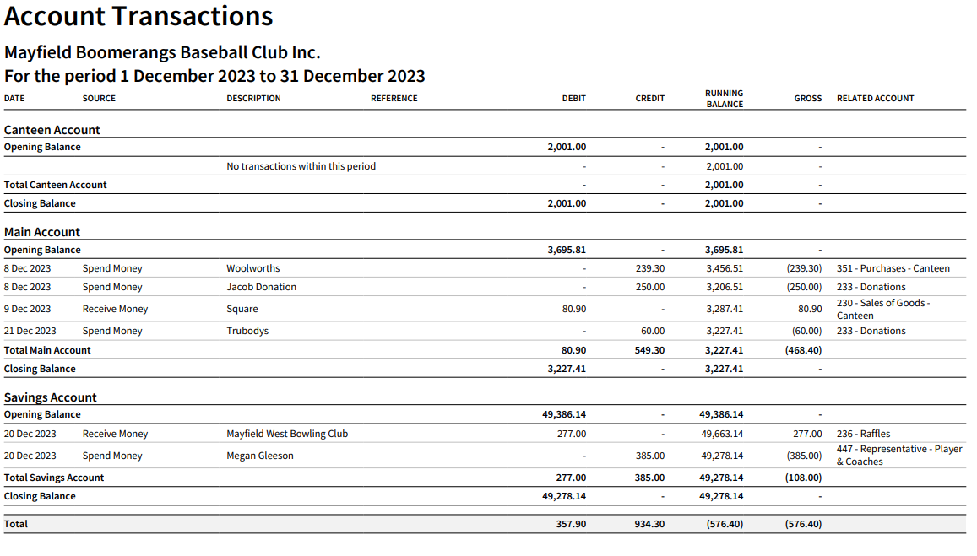
Moved: Grant Harris| Seconded: Ann Voigt

NBA Report
- No NBA meeting to report

Agenda
- Sponsorship Banners
- Committee discussed need to approach new sponsors and be organised early to arrange banners.
- Vistaprint suggested as potential banner manufacturer.

- Good Sports Policy Update
- Jake notified committee that he had completed the Good Sports Policy requirement to book ground for pre-season training.
  - Notified committee that during the process he had needed to change the MBBC ServiceNSW password.

- Bunnings BBQ
- Committee discussed pros and cons of running a Bunnings BBQ fundraising event.
  - Location and value for effort discussed. Prior experience suggests too much work involved for little return.

- Sports Summit Attendees
- Committee discussed which members wished to attend upcoming Newcastle City Council Sports Summit event.
  - Jake and Grant volunteered to attend. Jake to RSVP by 25th Jan.
  - Possible topics to discuss on behalf of MBBC at event: lack of accessible amenities, lack of change room, floodlights for baseball/softball field.

- Coaches, Managers, Scorers
- Discussed importance of having coaches, managers and scorers organised early in the year.
  - Little league verbal expression of interest: Johnny would like to be an assistant coach.
  - Jake to reach out to Mark Anderson regarding Junior League coaching.
  - Jake to email junior parents calling for EOI. Post to Team app also.
  - No EOI’s for senior coaching yet
- Scoring and gamechanger discussed
  - Megan knowledgeable in gamechanger and is happy to assist with training new scorers with the software.

- Pre-season Field Maintenance
- Committee discussed need to arrange a date for field maintenance closer to beginning of season.
- Discussion regarding dirt for the infield had
  - Before purchasing, Jake to email other clubs and softball to ask if they are interested in purchasing excess dirt. Matt to provide Jake with information regarding previous quote.

- Lonn Cooper Email
- Committee discussed recent correspondence received by club member Lonn Cooper
  - Grant to draft a formal email addressing shortcomings regarding this issue.

- Budget Draft
- Joel presented draft budget to committee.
  - Suggestion made that committee create revision dates to ensure proposed budget on track throughout the year.
  - Committee asked to consider suggestions regarding expenditure milestones.
- Budget item regarding equipment expenditure discussed.
  - James & Josh N to look at previous equipment inventory and prioritise items required for purchase.
- Committee discussed option of potentially offering payment for imported players.
- Budget item regarding club component of playing fees discussed.
  - Active Sports Vouchers will further lower junior club component to $25.
  - Motion to accept proposed amounts of $75 for all junior players & $175 for all senior players was passed unanimously.
  - Joel and Pettigrew’s Family Funerals made offer to sponsor the difference for junior players, dropping required amount to be paid by junior members $0.
    - Jake to email all members notifying fee changes, including comparison to last year
    - Jake to update website.
    - Elaine to promote new pricing on socials, including appreciation to Pettigrew’s.

General Business
Joel
      - Informed committee that he will send invoices for creation of sponsorship hampers.
Chris
      - Proposed that a round table will be more effective for meetings.
      - Raised the importance of locking in volunteers for upcoming come and try days.
John
      - Reinforced urgency regarding appointing coaches and scorers
      - Identified need to encourage more player engagement with major sponsors this season.
      - Next MWBC raffle night is coming up
        - Volunteers and advertise on socials.
Ann
      - Suggested possibility of moving surplus funds into high interest investing account
Jake
      - Discussed need for junior gloves for come and try days.
      - Batting tees were also identified as items needed for purchase.
        - Jake to talk with Josh, James and Matt to arrange purchases before upcoming come and try days.

Actions Arising (Summary)

Action: | Member/s Responsible: | Complete by:
Deposit cash made from MWBC twilight markers | Matt | 19th January
Create letter in response to Lonn Cooper | Grant | 23rd January
Send thank you letter and yearbook to previous sponsors | Elaine & Jake | 23rd January
Arrange purchase of junior gloves and batting tees | Jake, Josh, James & Matt | 23rd January
Attend Greater Bank Hamilton to sign off accounts transfer | Joel | 23rd January
Notify club regarding adjusted club fee component via email, website & socials | Jake & Elaine | 23rd January
Sports Summit | Jake & Grant | RSVP: 25th January  Event: 7th February
Email other clubs regarding purchasing infield dirt | Jake | 30th January
Create inventory and prioritize equipment for purchase | Josh & James | 30th January
Clarify 2024 NBA proposed game day scenarios with Duane to assist committee voting preferences. | Jason | 30th January
Follow up and identify requirements for liquor license renewal | Jason & Stephen | 30th January
Clarify issues with Gamechanger regarding scoring of junior games | Jason & Megan | 30th January
Enquire about club attainment of wi-fi modem from Optus to assist in canteen and scoring duties | Jason | 30th January
Contact RSA provider for potential dates in late Feb/Early March | Joel | 30th January
To seek possibilities regarding temporary batting cage | All Members | 30th January
Complete in-season ground booking with council | Jake | 30th January
Purchase Gamechanger subscription | Matt | 30th January
Purchase defibrillator | Jane & Matt | 30th January
Reach out to Mark Anderson re coaching JL  Post on team app calling for last season junior parents coaching EOI | Jake & Josh | 30th January
Organise Coles Return and Earn initiative | Matt | 5th March
Potentially organise Boomerangs team to compete at Tamworth in June carnival | Josh | 15th May
Consider club goals for various areas of the club’s running to promote long term success and improvement. | All Members | Ongoing

Next Meeting
30/01/2024 | 7pm, Mayfield West Bowling Club
Motion to adjourn was made at 8:57 pm and was passed unanimously.

