Mayfield Boomerangs Baseball Club
w: www.BoomerangsBaseball.com.au
e: MayfieldBoomerangs@Gmail.com
President: Jason Picot
Senior Vice-President: Richard Campbell
Junior Vice-President: Grant Harris
Secretary: Joshua Voigt
Treasurer: Ann Voigt
ABN: 95511551016
Incorporation Number: Y0998138

Meeting Minutes
Date | time 05/09/2023 7:05 PM | Meeting called to order by Jason Picot

Attendance
Attendees: Jason Picot (President), Richard Campbell (Snr Vice President), Grant Harris (Vice President), Joshua Voigt (Secretary), Ann Voigt (Treasurer), John Mossop, Jake Bramble, Kerrie Metcalfe, Tanya Picot, Matthew Reeves, Benjamin Reeves
Apologies: Elaine Scotney, Stephen Petherbridge, Virginia Petherbridge, Joel Pettigrew, Ty Johnstone, Jane Frank

Approval of Minutes
- The previous minutes for the 15/08/2023 were presented and approved.
Moved Grant, Seconded Richard

Business Arising from Previous Minutes
- Jake has yet to send the umpire feedback to the NBA.
- Sent in Umpire of the year nomination.
- Jason still talking with Garry about Right Field
- Josh to follow up the ASF Batting Tunnel setup.
- Sponsor’s day was a success, big thanks to Elaine.
  - All the sponsors who showed up appeared to have a good time.
- Mission Statement is now up on the website.
- Letter to Lonn has yet to be sent, Jason has drafted a letter for review.

Treasurer’s Report
MBBC Inc. Main Account | 782236229 | MBBC Inc. Canteen Account | 72138541
Opening Balance: 15/08/2023 | $6,808.20 | Opening Balance: 15/08/2023 | $6,808.20
Incoming | $5,847.45 | Incoming | $5,847.45
Expenses | $6,608.24 | Expenses | $6,608.24
Closing Balance: 04/09/2023 | $6,047.41 | Closing Balance: 04/09/2023 | $6,047.41
MBBC Inc. Savings Account | 721808947 | Total Balance
Opening Balance: 15/08/2023 | $6,808.20 | $54,096.85
Incoming | $5,847.45
Expenses | $6,608.24
Closing Balance: 04/09/2023 | $6,047.41
Moved Ann, Seconded Kerrie

Correspondence
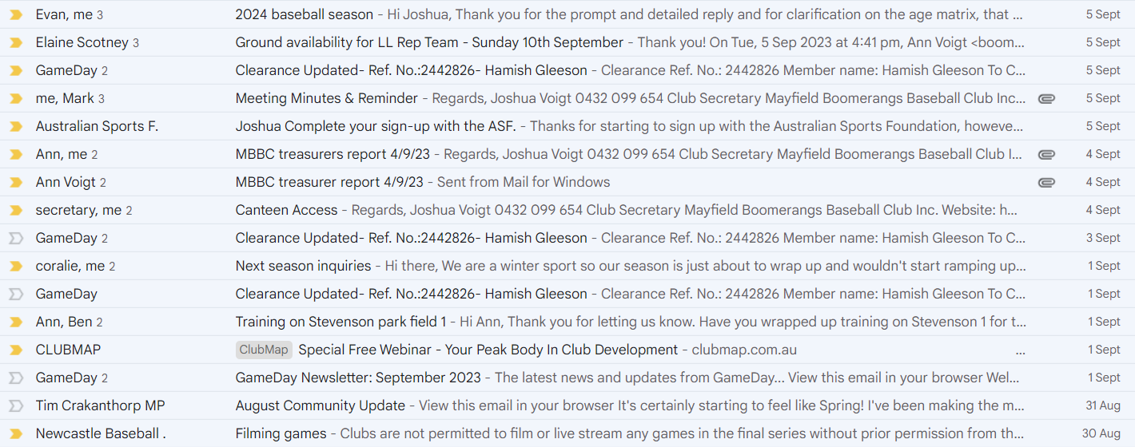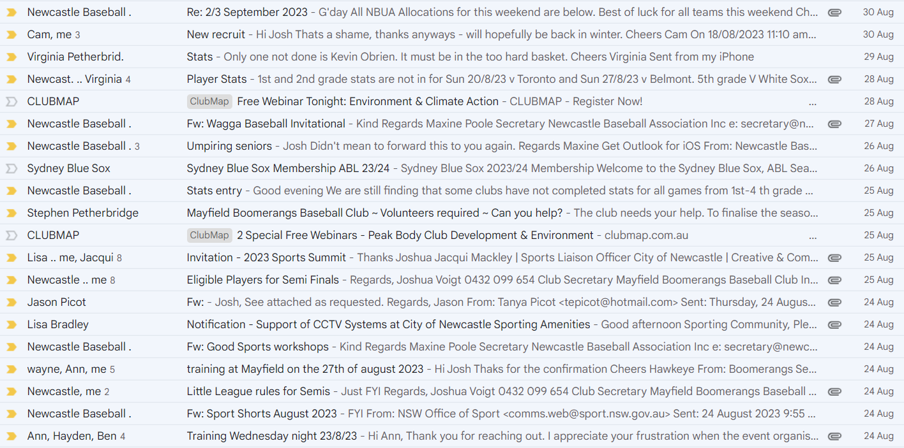
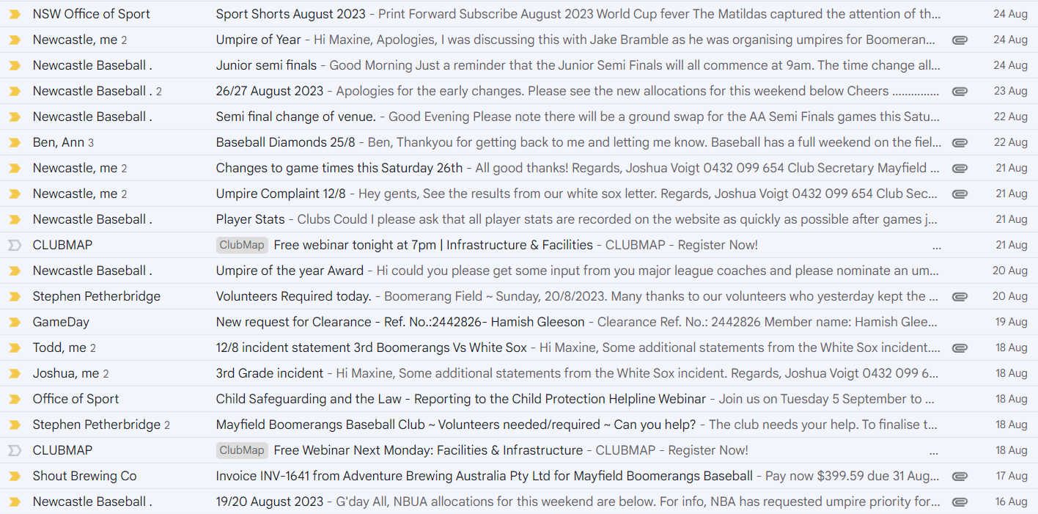
Moved Joshua, Seconded Jake

Agenda
  - NBA Board Representative
- Need to investigate having someone take up the role ready for next season.
  - Grand Final SL/LL
- Saturday @ Windsor – Senior League 9am (Boomerangs vs Toronto/Phoenix)
- Sunday @ Boomerangs Field – Little League 9am (Phoenix vs Boomerangs)
  - Idea to have them on the main diamond.
  - Jason to check on accessing a net from the NBA to set up behind the plate (shorten the distance).
  - Need to have some hands to help reset the field ready for 2nd grade.
- In the event of a washout at Windsor, Boomerangs are the backup field for SL/3s/4s.
Major League Preliminary Final
- We need support from all members.
- Need to reach out to all parents/players/volunteers to get bodies there.
  - Need groundwork assistance.
  - RSA/Food Handling.
Presentation
- 14th October – Juniors & Seniors
  - Juniors – Outside/on the green
  - Seniors – 6:30 for 7pm
- Need to set up a TryBooking event for senior presentation,
  - $10 entry fee
  - cutoff date 6th October.
Trophies
- Need to organise trophies to be returned.
- Also need to organise a meeting to discuss novelty ones.
- Ann has partially ordered medallions/trophies/steins.
- John will talk to Ian Fogarty to see if he will be able to handle club person of the year votes.
Canteen Handover
- Softball have asked for a date to have access to the canteen.
- Need a hand to move things midweek (Wed 13th September)
- Softball will buy additional stock (chips/drinks/etc.)
Uniform/Equipment returns
- Need to get uniforms off junior players if they need to return some uniforms.
- Kit bags to go back into the gear shed for Matt/Ben to check out.
Toronto 75th Anniversary
- 21st October at Toronto Diggers
- Would be good to have a Boomerangs (committee) Table.
Toronto Masters
- Week after Major League Grand Final
- Boomerangs numbers seem pretty good.
- Need to put in team entry.
Season Review
- Jason would like to sit down and discuss the season and evaluate how it went.
- Potentially 8th of October at Shout

General Business
N/A – Grant, Jake, Ben, Matt, John, Ann, Tanya, Kerrie, Jason
Joshua:
- Jake on music duties for Major League Final
- Will be looking to use the new BBQ for pancakes in the morning for the juniors.
- Have organised Keg for Sunday (Minnow – Mid Strength), needs pickup.
Richard:
- Club Raffles are getting massive praise and good support.
- Wanted to get an update on the Batting Tunnel
  - Jason has discussed it with Joel and is on hold.
- Wanted to get a list of potential projects on the field that we can approach.
  - Mounting boot cleaners
  - Leftfield Dugout roof missing
  - Might need extra diamond dirt for the field.

Next Meeting
10/10/2023 @ 7:00 pm @ Mayfield West Bowling Club
The motion to adjourn was made at 8:25 pm and was passed unanimously.

Action List
Task | Who | Due Date
Contact NDSA about ground repair/catchup | Jason Picot | ASAP
Australian Sports Federation for Batting Tunnel Fundraising updates | Joshua Voigt | Next Meeting

