Mayfield Boomerangs Baseball Club
w: www.BoomerangsBaseball.com.au
e: MayfieldBoomerangs@Gmail.com
President: Jason Picot
Senior Vice-President: Richard Campbell
Junior Vice-President: Grant Harris
Secretary: Joshua Voigt
Treasurer: Ann Voigt
ABN: 95511551016
Incorporation Number: Y0998138

Meeting Minutes
Date | time 15/08/2023 7:05 PM | Meeting called to order by Jason Picot

Attendance
Attendees: Jason Picot (President), Grant Harris (Vice President), Joshua Voigt (Secretary), Ann Voigt (Treasurer), John Mossop, Elaine Scotney, Jake Bramble, Jason Bartlett, Mark Sinclair, Stephen Petherbridge, Virginia Petherbridge, Jane Frank, Kerrie Metcalfe,
Apologies: Richard Campbell (Snr Vice President), Ty Johnstone, Joel Pettigrew,

Approval of Minutes
- The previous minutes for the 11/07/2023 were presented and approved.
Moved Stephen, Seconded Tanya

Business Arising from Previous Minutes
- Virginia is still waiting for help from Travers about results on the NBA website.
- Jason has been in contact with Garry, has got some plans in place to fix things – Jason to follow up.
- Mark had a look through the sportsground hire agreement.
  - The council doesn’t seem to claim responsibility for anything.
  - The batting tunnel is part of the agreement/licensing.
  - The council is supposed to mark the field for the first time each season.
  - Has looked on the website to find any public information about what responsibilities the council have in terms of maintaining the grounds/facilities.
  - The council does supply paint for line marking and mows the outfield somewhat regularly.
- Jake has done a draft for the umpire structure feedback to send to the NBA, will send it out for a review asap.
- Josh is on hold with the sporting fundraising for the tunnel.
- Jason B has got most of the work done, going to send out the
- Most of the outstanding fees have been fixed up (minus two players)
- Sponsors day invites have gone out via email, Elaine will follow up with attendance.
  - We need to get some player support to help look after the sponsors day activities.
  - The next two Sundays have been set up.
- Mark has looked at the roster, bit difficult to set up in TeamApp.
  - Will investigate it during the offseason.
- Bricks for the mound and batters’ box were installed on the Country Championships weekend.
  - All reports were that the fixes were done extremely well.
- Pretty mission statement will go up on the website asap.

Treasurer’s Report
MBBC Inc. Main Account | 782236229 | MBBC Inc. Canteen Account | 72138541
Opening Balance: 10/07/2023 | $5,580.41 | Opening Balance:10/07/2023 | $8,673.17
Incoming | $9,377.38 | Incoming | $5,709.20
Expenses | $8,149.59 | Expenses | $2,650.46
Closing Balance: 14/8/2023 | $6,808.20 | Closing Balance: 14/8/2023 | $11.731.91
MBBC Inc. Savings Account | 721808947 | Total Balance
Opening Balance: 10/07/2023 | $36,200.93 | $51,597.42
Incoming | $8,881.90
Expenses | $12,025.52
Closing Balance: 14/8/2023 | $33,057.31

Moved Kerrie, Seconded: Grant

Correspondence
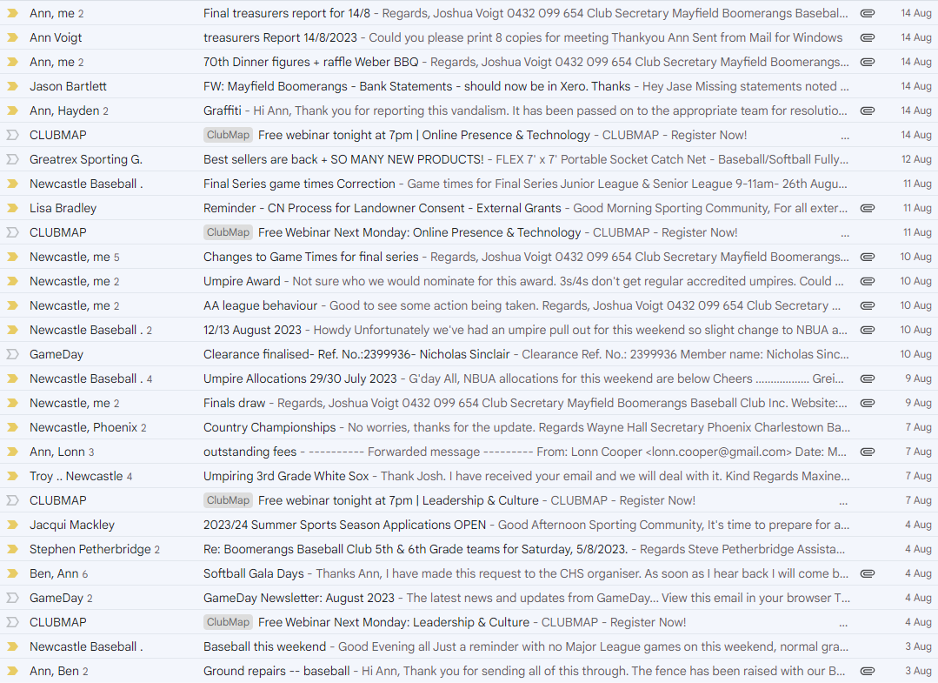
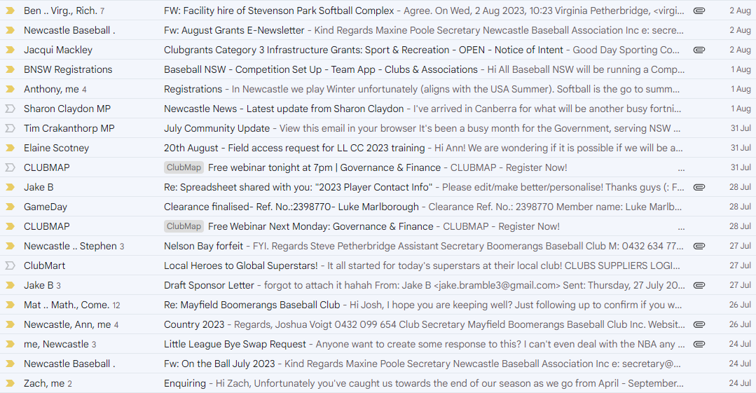
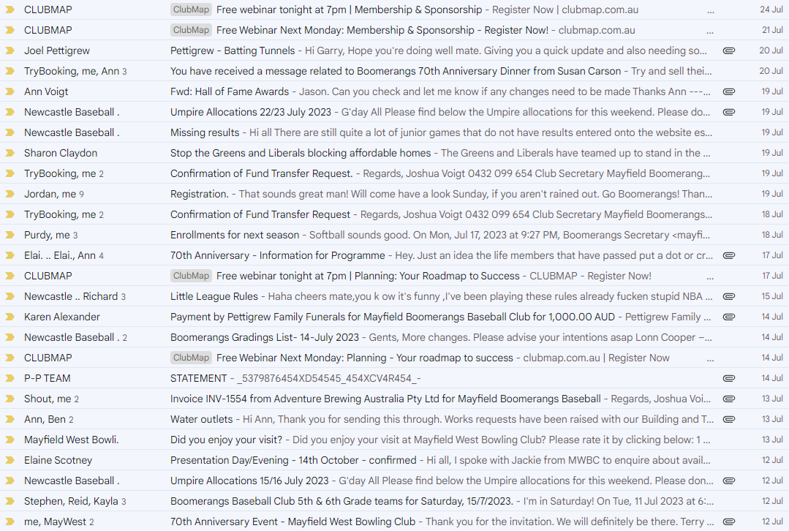
Moved Stephen, Seconded: Jake

Agenda
  - Lonn Cooper Letter
- The letter was discussed.
- An acknowledgment response will be drafted focusing on the way we handled the representative issue.
- Half fees to be accepted.
- The possibility of inviting him to sponsor day/s.
  - 70th Anniversary Wrap
- All reports said it was a great night.
- Thanking the ladies (Jane, Elaine, Tanya, Ann0
- Thanking the 70th Committee
- Thanks to Tony for being MC.
- Thanks to Hudson for selling merchandise on the night.
- Thanks to Wilson for selling a massive amount of raffle tickets and coincidentally winning the BBQ.
- Unfortunately the night did run at bit of a loss (~$1500)
- The Weber raffle was a big success.
- Would like to send an email of thanks.
  - To the Life Members
  - To the new Hall of Famers
  - Clubs that attended.
  - Batting Tunnel / Grant Update
- Joel was not present at the meeting so there was a brief discussion on available grants.
  - Finals Allocation – Roster
- Saturday 26th August – Major Semi Final for 3s/4s, Semi Final for Senior League.
  - 1s/2s/5s/6s need to be rostered on.
- Sunday 27th August – Semi Final for LL, Mick Hassett Cup Day vs Belmont for 1s/2s.
  - 3s/4s/5s/6s need to be rostered on.
- Sunday 10th October – Preliminary Final for 1s/2s, Grand Final for LL.
  - Need all hands-on deck.
  - Presentations - Snr - Jnr
- Elaine has organised the Junior/Senior presentation for Saturday 14th October.
  - Juniors: 11am – 2pm (BBQ Lunch)
  - Seniors: 6:30pm for 7pm
- Send out email to previous trophy recipients.
- Need junior jerseys returned.
- Must contact West Site Bistro about catering – Ann.
  - Sponsors & Hassett Day
- Have emailed sponsors – will chase them up.
- Johnny was looking to get a 400 Optus sign up on the outfield fence.
- Has asked each sponsor if they wish to bring some promotional items to sell.
- Need to talk to Joel about potential marquee/chairs.
- First pitch throwing by Johnny before 1s.
- Need lots of volunteers for these days.
  - Scoring Issues
- Virgnia has a bunch of things we need to update in the database to send to the NBA.
- Stephen questioned why can’t either team add the results onto the database.
  - Letter White Sox 3’s
- A letter was submitted from Troy Carter regarding the behaviour of a Sox player.
- Is with the NBA and are looking for other witness statements.
  - Broadcast of games
- Would be awesome if we could broadcast some of the final’s day.
- Next two Major League games could be streamed.

General Business
N/A – Grant, Matt, Jake, Virginia
Joshua:
- Raffle on this Friday
- To organise Keg for 10th October & Mick Hassett
- Music on the 10th
Stephen:
- Turned up at the Junior League game to take photos last Saturday.
  - Senior League is this Saturday at Home (8:30am)
  - Teeball/Zooka this Sunday (9am)
Kerrie:
- Clare Tolcher has said she would be interested in learning to score.
- The heater in the scorer’s hut has started to not work.
Ann:
- Kit bags will be returned shortly, need to do a stock take, and possibly lock the kits to prevent them being ransacked over the off season.
- Thanked 1st grade for their efforts packing up and fixing the ground after the game.
John:
- Would also like a Keg for Mick Hassett cup day.

Next Meeting
29/08/2023 @ 7:00 pm @ Mayfield West Bowling Club
The motion to adjourn was made at 8:59 pm and was passed unanimously.

Action List
Task | Who | Due Date
Contact NDSA about ground repair/catchup | Jason Picot | ASAP
Australian Sports Federation for Batting Tunnel Fundraising updates | Joshua Voigt | Next Meeting
Discuss/Organise Sponsors Day | Jake Bramble &  Elaine Scotney | Next Meeting
Get updates on mission statement (get on website) | Grant Harris | ASAP

