Mayfield Boomerangs Baseball Club
w: www.BoomerangsBaseball.com.au
e: MayfieldBoomerangs@Gmail.com
President: Jason Picot
Senior Vice-President: Richard Campbell
Junior Vice-President: Grant Harris
Secretary: Joshua Voigt
Treasurer: Ann Voigt
ABN: 95511551016
Incorporation Number: Y0998138

Meeting Minutes
Date | time 13/06/2023 7:10 PM | Meeting called to order by Jason Picot

Attendance
Attendees: Jason Picot (President), Grant Harris (Vice President), Joshua Voigt (Secretary), Ann Voigt (Treasurer), John Mossop, Mark Sinclair, Jake Bramble, Stephen Petherbridge, Virginia Petherbridge, Kerrie Metcalfe, Jane Frank, Tanya Picot
Apologies: Richard Campbell (Snr Vice President), Elaine Scotney, Matthew Reeves, Ty Johnstone,

Approval of Minutes
- The previous minutes for the 16/05/2023 were presented and approved.
Moved Joshua, Seconded Stephen

Business Arising from Previous Minutes
- Couple of double ups attendees/apologies.
- A bat was returned, still missing a silver Easton Bat
- Still no date for NDSA catchup. (Fridge, Grass Repair @ RF, Chat around Tunnel) Jason to chase up.

Treasurer’s Report
MBBC Inc. Main Account | 782236229 | MBBC Inc. Canteen Account | 72138541
Opening Balance: 16/05/2023 | $14,214.78 | Opening Balance: 16/05/2023 | $6,638.11
Incoming | $5,552.26 | Incoming | $1,645.27
Expenses | $11,579.64 | Expenses | $907.44
Closing Balance: 13/06/2023 | $8,187.40 | Closing Balance: 13/06/2023 | $7,375.94
MBBC Inc. Savings Account | 721808947 | Total Balance
Opening Balance: 16/05/2023 | $26,068.42 | $46,593.37
Incoming | $4,961.61
Expenses
Closing Balance: 13/06/2023 | $31,030.03

MBBC Inc. Main Account:
Expenses: |  | Incoming:
Emmssee green Belts Umpire Fees (Parish, Newsome) 4/3. 20/5  Transfer AKV  Onya Clothing (half order)  Coles Trivia night  Umpire fees 4/3 27/5  Umpire Fees 2/1 28/5  Sq Transfer Canteen 27/5  Transfer Trivia 27/5  Refund T Preston  NOC ground fees  Umpire fees 6/5  Norco (line powder)  Woolworths (um fees) 2/1 4/3 27,4/6  I Bolton umpire fees 2/1 4/6  Sq transfer 3/6 canteen  Microsoft club laptop  Emmsee (players hats 36) | $197.00  $100.00  $2,210.00  $1,591.00  $77.70  $100.00  $120.00  $314.00  $465.00  $55.00  $3,816.90  $90.00  $25.80  $220.00  $120.00  $791.24  $109.00  $1,177.00 | Game day regos  Clothing Darnell  Try Booking  Game Day regos  Service NSW  Fees  Fees  Square  Square 27/5 (jumpers)  Sq 29/5 Canteen  Sq 3/6  Stubby holders x 5  70th – Trubody G&K x 2  70th – Gallucci D&J x 2  70th – Rowe x 2  70th – Mossop R&S x 2  70th – Fisher R & J x2  70th – Fisher K  70th – Rippon S & C x 2  70th – McLellan J & B x 2  70th – Rippon K x 3  70th – Lambkin J  70th – Hassett C  70th – Petherbridge S&V x 2 | $219.73  $150.00  $0.96  $76.67  $200.00  $69.40  $75.00  $603.28  $1,071.48  $334.50  $1,371.24  $50.00  $120.00  $120.00  $120.00  $120.00  $120.00  $60.00  $120.00  $120.00  $180.00  $60.00  $70.00  $120.00

MBBC Inc. Canteen Account:
Expenses: |  | Incoming:
Liquor BWS  Canteen sales transferred 4/6  Woolworths  BWS liquor  Shout brewing co | $87.35  $77.10  $149.60  $327.00  $266.39 | Try booking.  Ump fees 2/1 28/5  Sq transfer 27/5  Canteen 27/5  Sq canteen 3/6  Cash 3/6 | $0.03  $120.00  $314.00  $100.00  $791.24  $320.00

Savings Account
Expenses: |  | Incoming:
 |  | Bryant Built (sponsorship)  MWBC raffle  Try Booking  AKV transfer from 2022.  Trivia Night 27/5  Trivia Night (slides)  Sq Trivia 27/5 | $1,000.00  $246.00  $0.61  $2,210.00  $900.00  $140.00  $465.00
Moved Ann, Seconded Virginia

Correspondence

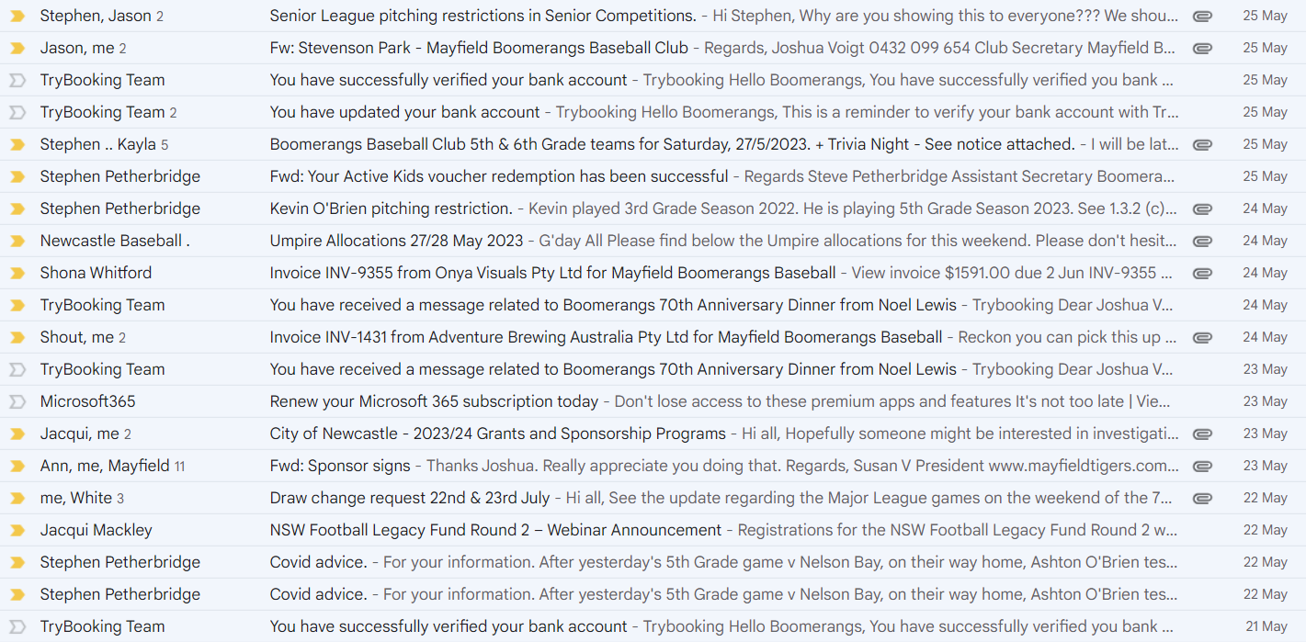
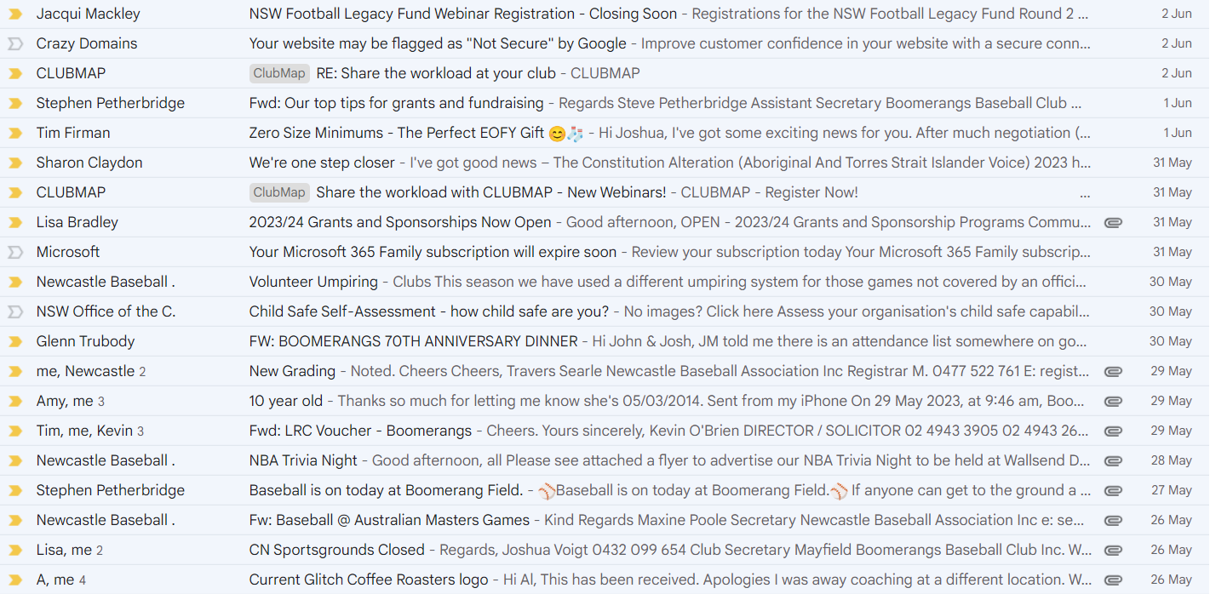

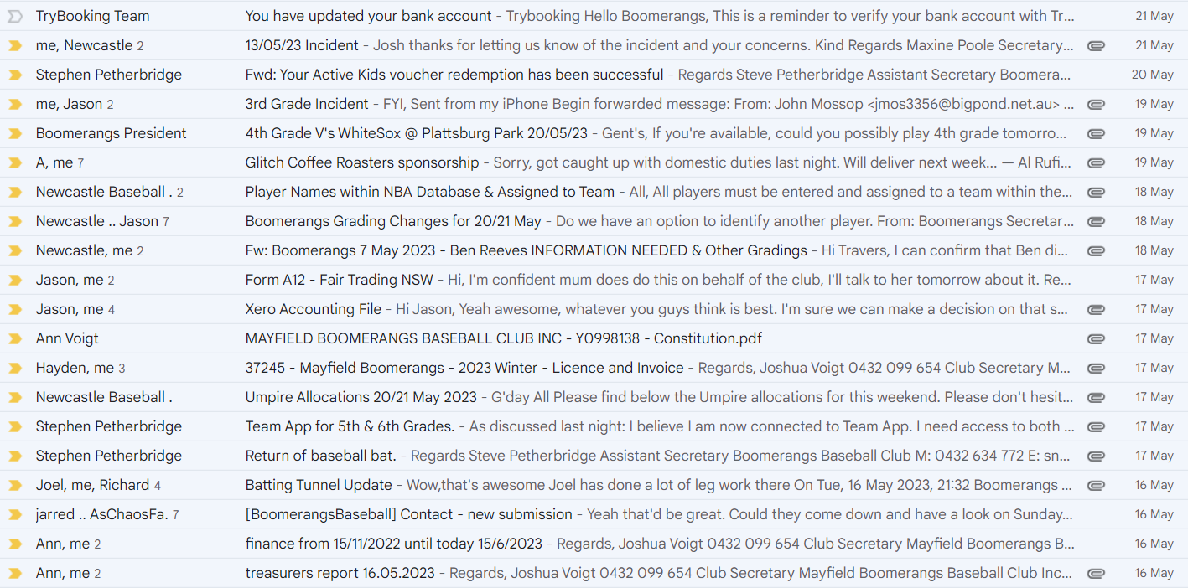
Moved Josh, Seconded: Stephen

Agenda
  - Batting Tunnel Updates
- Email from Council circulated to committee.
- Will be looking to replace the tunnel with new design (per Joel Pettigrew)
- MBBC and NDSA to go halves with outside sponsors to donate money also.
- Grant to write a grant application using Joel Bryant’s plan to do stage 1 (removal of tunnel)
  - Fundraising
- Jason Bartlett is interested in setting up an Australian Sports Foundation (ASF) project for tax deductible donations. (5% admin fees)
- Motion to set up the Batting Tunnel Project on ASF
- Possibility to set up tiers (bronze -$110/silver - $275/gold - $550 bricks) for players/businesses.
  - Xero Accounting Package
- Makes the treasurer’s job a lot easier - can manage invoices/receipts & downloads all figures automatically.
- Cost is approximately $28/month & Jason Bartlett was prepared to cover the costs for 2 years (under his business)
- Motion to allow Jason Bartlett (with Ann’s assistance) to set up Xero for the club.
- The club appreciates Jason’s efforts.
  - Club Finances
- Jason Picot was curious about the player finances – was everyone up to date with club payments.
- Can all players be notified of their debts?
  - Social Events
- Stephen wanted to show his admiration about the Trivia Night & all those involved were thanked.
- The first sponsor’s day to be 25th June on Sunday vs Toronto to be postponed. (Potential 27th August – Mick Hassett Day)
- Main sponsor’s day is the 16th of July vs Phoenix, need to get all club members to come to MWBC after the games.
- Jake Bramble (& assoc.) to come up with ideas to celebrate our sponsors (snack platter, first pitch, promotion)
- Old Boys Day (23rd July) is to be the following the 70th Friday (21st July)
- Need to set up a junior social event – Jake to follow up.
  - Duty Roster
- Stephen has put together a roster of players for canteen duties.
- Mark/Kristyn to sort out Duty Roster on teamapp
  - Weber Raffle
- Boomerangs coloured Weber was donated by Damien Rounce for Trivia Night.
- The idea was to use it as a big raffle to be drawn on the 70th anniversary.
- 120 Books, 10 tickets per book, $2 per ticket ($20/book)
- Tanya to create ticket books (Josh to do design)
  - Ground Maintenance
- Pitching mound needs work done – holes getting bad.
- We need unfired clay bricks (about 20/24)
- Need a trip to Taree to pick them up.
  - 70th Event
- Josh has written a letter for the life members.
- Approx 45 tickets sold (not many current players)
- Life Members to be inducted.
- Costs involved.
- Commemorative merchandise to be sold.
  - Commemorative caps – no money to be spent now (hats to be ordered on the night)
  - Table coasters & bottles – ($500)
  - Table decorations – Jane Frank to do decorations ($500)
- Stubby Holders are already to be sold.
  - Additional Training Night
- Josh to chase up an additional training night with Newcastle Council (Friday evenings)

General Business
Jake:
- Had an umpires events scheduled with Mark Gilmour, needs to promote it on socials.
  - Targeting our players but could open to other clubs/association.
Ann:
- Spoke to Travers about Virginia scoring for both teams, was told that the NBA isn’t concerned about 5th/6th grade stats.
Kerrie:
- Sent an email to Travers about 2nd grade results.
John:
- Life Members – everyone is entitled to nominate a life member.
  - Doesn’t have to happen at the 70^{th.}
- Hall of Fame inductees – Potential for 5 nominations.
Megan:
- Sunday 25th June no T-ball/Zooka coaches.
Jason:
- Need to organise a junior team photos day.
- 70th meeting on Monday 19th
- Governance meeting on Tuesday 20th

Next Meeting
11/07/2023 @ 7:00 pm @ Mayfield West Bowling Club
The motion to adjourn was made at 9:35 pm and was passed unanimously.

Action List
Task | Who | Due Date
Contact NDSA about ground repair/catchup | Jason Picot | ASAP
Review Ground Usage Agreement | Mark Sinclair | ASAP
Discuss/Apply for Recreational Facilities Grant | Grant Harris | ASAP
Give Feedback to NBA re. Umpire Structure | Jake Bramble | ASAP
Investigate tunnel fundraising options for 70th | Jason Bartlett | ASAP
Investigate Australian Sports Federation for Batting Tunnel Fundraising | Joshua Voigt | Next Meeting
Setup Xero for treasurer purposes | Jason Bartlett  & Ann Voigt | ASAP
Chase up players with outstanding fees | Ann Voigt | ASAP
Discuss/Organise Sponsors Day | Jake Bramble &  Elaine Scotney | Next Meeting
Discuss with Jackie (MWBC) about junior social night | Jake Bramble | Next Meeting
Setup Duty Roster on TeamApp | Mark Sinclair | ASAP
Print/Cut/Distribute Weber BBQ Raffle Tickets | Joshua Voigt  & Tanya Picot | ASAP
Investigate options to source unfired clay bricks for mound/batter’s box | Multiple | ASAP
Organise to have some 70th Printouts to be put up at home games/handed to players | Grant Harris &  Elaine Scotney | ASAP
Get updates on mission statement (get on website) | Grant Harris | ASAP
Promote umpires’ session EOI on socials | Elaine Scotney | ASAP

