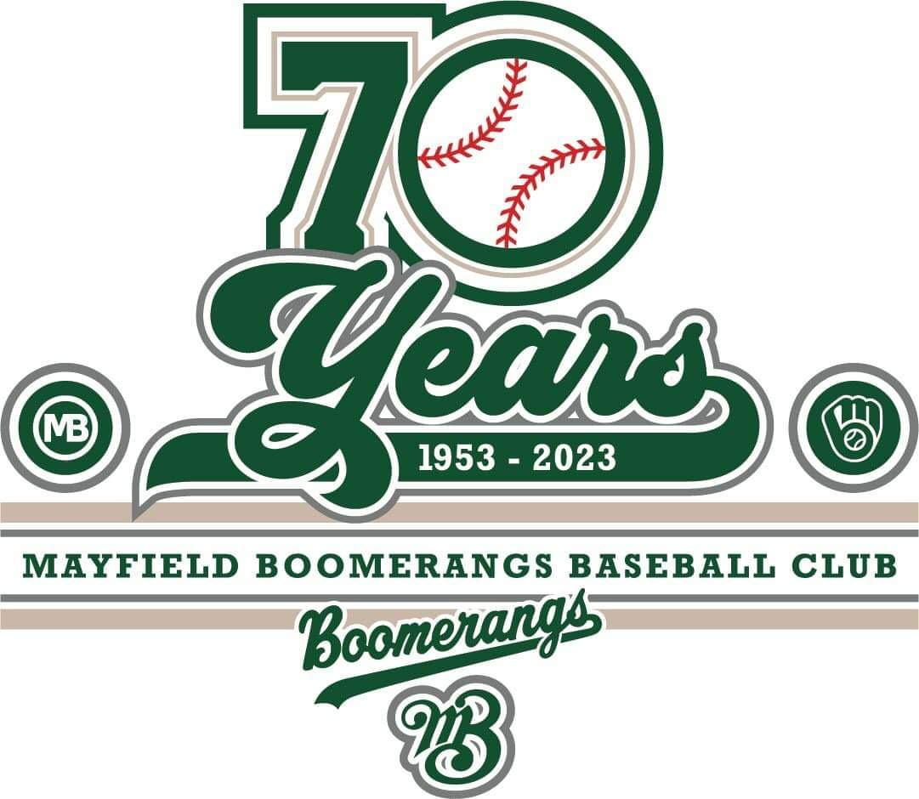
Mayfield Boomerangs Baseball Club
w: www.BoomerangsBaseball.com.au
e: MayfieldBoomerangs@Gmail.com
President: Jason Picot
Senior Vice-President: Richard Campbell
Junior Vice-President: Grant Harris
Secretary: Joshua Voigt
Treasurer: Ann Voigt
ABN: 95511551016
Incorporation Number: Y0998138

Meeting Minutes
Date | time 28/03/2023 7:10 PM | Meeting called to order by Jason Picot

Attendance
Attendees: Jason Picot (President), Richard Campbell (Snr Vice President), Grant Harris (Vice President), Joshua Voigt (Secretary), Ann Voigt (Treasurer), John Mossop, Matthew Reeves, Ben Reeves, Jane Frank, Elaine Scotney, Megan Gleeson, Jake Bramble, Kerrie Metcalfe, Fiona Hinton-Rogers, Craig Reeves
Apologies: Mark Sinclair, Ty Johnstone, Stephen Petherbridge, Virginia Petherbridge,

Approval of Minutes
- The previous minutes for the 15/03/2023 were presented and approved.
Moved Josh, Seconded Rich

Business Arising from Previous Minutes
- Savings account closing balance same as opening balance – fixed.
- Action List:
  - Coaches’ nominations have been mostly sorted.
    - 1st Grade – Jason Bartlett
    - 2nd Grade – Steve Harris
    - 3rd Grade – Joshua Voigt
    - 4th Grade – Jason Picot
    - 5th Grade – Stephen Petherbridge (Mark)
    - 6th Grade – Stephen Petherbridge (Fiona)
  - Jason called Nick Z and was unable to reach him and got no calls back.
  - Dan Gleeson found documentation.
  - John was able to go to Greater Waratah.

Treasurer’s Report
Due to this being a special meeting a formal treasurer’s report was not presented.

Correspondence
- Comedy for a Cause EOI email
- Orlando Bennett request to play down.
- Hawkeye price lists
- Certificate of Currency from Stephen Petherbridge
- WWC Numbers
- Liquor License from Stephen Petherbridge
- NBA Update By-Laws
- Sponsorship Invoice sent to Optus Raymond Terrace (Johnny Tolcher)
- NBA Season Dates
- Registration Issues
- Active Kids Voucher redemption.
- Life Membership Document (Ian Fogarty)
- Council lock on building update
- Gameday Sportswear Order Report
- Sam Jordan clearance approval from Phoenix
- Graffiti in 1b Dugout report to NCC
- NBA Baseballs and Scorebooks
- Request to play out of age.
- NBA Website entry
- Kevin O’Brian dispensation request
- NBA By-laws update and QR codes.
- NDSA meeting request response.
Moved Josh, Seconded: Stephen

NBA Report
- New Registrar (Travers Searle) is going to be watching the gradings more thoroughly and strictly this year.
- QR codes have been sent out – idea to put them up in the dugout for easy access.
- NBA is chasing money from the past number of years with rep levies and clothing.
- Finals will be run over 3 weekends.
  - Major League 16th September @ Toronto
  - AAA 9th September @ TBA
  - Minors 2nd September @ TBA
- The draw for April will be released shortly.
  - 5s/6s – 18 Games
  - 4s/3s – 19 Games
  - 1s/2s – TBA
- Minor League has had a run across the plate to limit excessive scores.
- Junior numbers:
  - Belmont good din all but Senior League
  - We are good in all teams.
  - All other clubs are struggling.
- Gala days for the first two rounds are due to rep weekends.
- More use of gameday on an NBA.
- Wet weather number looked after by Andrew Gardner
- Umpires Fees – Majors $60, AAA $50, Minors $45
Presidents Meeting:
- Junior League & Senior League to have grand finals in front of 3s/4s Grand Final
- Unaccredited coaches will be monitored strictly.

Agenda
- Coaches
  - Two of our coaches have not been completely qualified and will not be able to fill those positions until sorted.
    - Fiona is going to stand in for Stephen for 6th Grade temporarily.
    - Jason asked Mark to look after 5th Grade temporarily.
  - By-Laws need to have club a Level C – Joshua Voigt has done the all the components apart from the registration/payment to the BNSW.
    - Motion to have the club fund the finances of to allow josh to obtain his level C as part of the club.
Moved by Jason, 2nd Richard, unopposed.
    - Josh to process getting his Level C through BNSW
- Equipment/kit bags
  - Discussion into the helmet situation, majority of players
  - Jason to action the order of helmets and remaining outstanding gear ASAP.
- Team App Communication
  - Mark and Kristen have been working to get the Team App to get setup with people in teams.
  - Josh to send an email to all members to make sure they get access to the Team App
  - The app will become the main source of truth for coaches/events/news/schedule/etc.
- Mission statement/NBA code of conduct (players sign)
  - Josh has put together some packs for coaches with the NBA code of conduct for all players to sign.
  - Would like to include the mission statement in the same so all players know what we expect from our players.
  - Advertising of Mission Statement on Socials/Website/Team App.
- Rosters/Duties
  - Need to find out what days people are available, being able to put people in a beneficial time slot.
  - Will need to work on getting organising umpires due to this new bylaw for home/away teams.
  - Grant to come up with a cost estimate and post to a to reach out to potential junior umpires.
- Apparel
  - Ordered additional gear.
    - Pants to be sold to players.
    - Jerseys due to abundance of new players
    - Undershirts to be ordered soon.
  - Matt asked questions about the cost of apparel from last season.
  - Polos have yet to be designed/ordered.
- Sponsorships
  - Tim Shakespeare (Rebel Chiropractic) has received an invoice for sponsorship for the same value as 2022 ($1k)
  - Josh to send Chris Frank (Orica) an email to chase up.
  - Richard has emailed Jacquie (MWBC) about following up the sponsorship.
  - Grant asked about what we need to do to show thanks from the club.
  - Jake mentioned getting an OPTUS Wi-Fi modem for the club to be used with the club square reader and gameday.
  - Additional potential sponsors still yet to come, would like to have more businesses approached.
- Social Events & Media
  - Posts to be not admin and to closed page, public page/club socials posts to be made by Elaine predominately.
  - Snuffy to get google drive for photos.
  - Jane admin assistance
  - Possibly looking at getting posts ready once the draw has been confirmed so that they are ready each week.
  - Ideas to get more interactions midweek.
    - ideas such as player profiles/interviews,
    - Junior & Senior player of the week
- Expenses & Procedures
  - Matt wishes to incorporate a more collective decision regarding the major club expenses going forward.
  - Matt to investigate additional options for apparel costings, specifically approximately 130 undershirts (e.g. Onya, Grenada)
  - Ben and Matt asked why fielding gloves were bought without their knowledge.
  - Jason has asked Matt & Ben to investigate creating policies/procedures that are specific to each position.
    - Grant to be involved to include governance information.

General Business
- Scorer’s meeting on Thursday at MWBC
- Certain players have only paid insurance, Ann will need to chase this up and potentially sort out payment plans.
- Soccer have asked to put sponsorship advertisement banners on the 1st base line.
  - Josh to contact soccer to organise a meeting regarding the banners.

Next Meeting
11/04/2023 @ 7:00 pm @ Mayfield West Bowling Club
Motion to adjourn was made at 9:15 pm and was passed unanimously.

Action List
Task | Who | Due Date
Josh to confirm WWC numbers with Service NSW | JV | ASAP
Jason to figure out date to meet with softball | JP | Next Meeting
Jason to sort out interim coaches for 5th/6th Grade | JP | ASAP
Josh to process getting his Level C through BNSW | JV | ASAP
Jason to action the order of helmets and remaining outstanding gear ASAP. | JP, AV | ASAP
Josh to send an email to all members to make sure they get access to the Team App | JV | EOW
Finalise Mission Statement and include with Code of Conduct Packs | GH, JV, ES | EOW
Grant to come up with a cost estimate and post to a to reach out to potential junior umpires | GH | Next Meeting
Inventory Stocktake to better understand outstanding apparel costs | AV, MR | No Date
Matt to investigate additional options for apparel costings, specifically approximately 130 undershirts (e.g. Onya, Grenada) | MR | ASAP
Matt & Ben to investigate creating policies/procedures that are specific to each position. (Grant to assist regarding governance) | MR, BR, GH | No Date
Ann to chase up players who only paid their insurance component. | AV | Next Meeting
Josh to contact soccer to organise a meeting regarding the banners. | JV | Next Meeting

