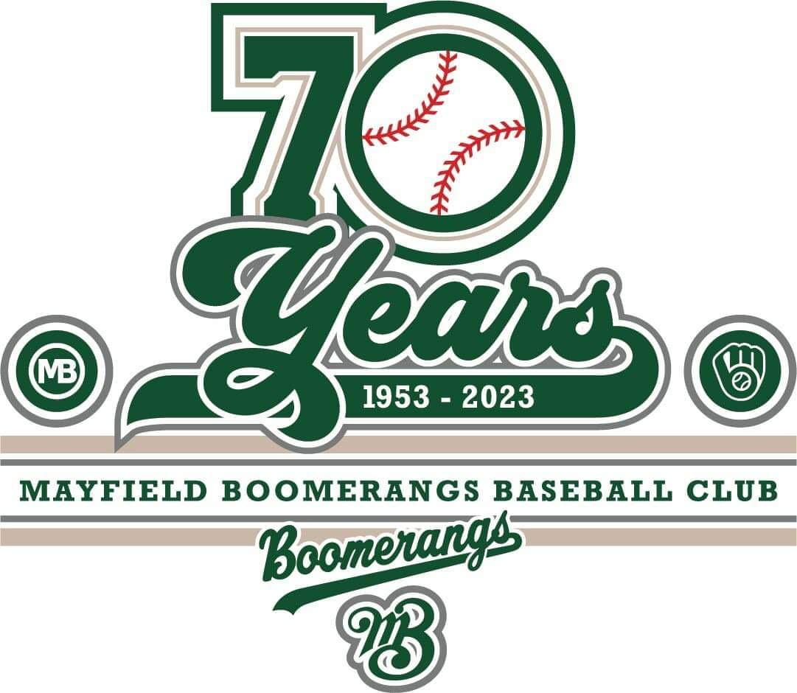
Mayfield Boomerangs Baseball Club
w: www.BoomerangsBaseball.com.au
e: MayfieldBoomerangs@Gmail.com
President: Jason Picot
Senior Vice-President: Richard Campbell
Junior Vice-President: Grant Harris
Secretary: Joshua Voigt
Treasurer: Ann Voigt
ABN: 95511551016
Incorporation Number: Y0998138

Meeting Minutes
Date | time 16/05/2023 7:10 PM | Meeting called to order by Jason Picot

Attendance
Attendees: Jason Picot (President), Joshua Voigt (Secretary), Ann Voigt (Treasurer), John Mossop, Mark Sinclair, Jake Bramble, Ty Johnstone, Stephen Petherbridge, Virginia Petherbridge, Matthew Reeves, Ben Reeves, Jason Bartlett, Craig Reeves
Apologies: Richard Campbell (Snr Vice President), Grant Harris, Elaine Scotney, Jane Frank, Kerrie Metcalfe

Approval of Minutes
- The previous minutes for the 18/04/2023 were presented and approved.
Moved Stephen, Seconded Virginia

Business Arising from Previous Minutes
- Ann – Trying to get a refund for the level C coaching payment (due to no course)
- Helmets/Chin Guards – They should have arrived/been delivered.
- Need to get Stephen Petherbridge on TeamApp for 5s/6s
- MUJFSC sponsor signs on 1st base pitching tunnel – need to send off email.
- NDSA didn’t come up with a date for catchup. (Fridge, Grass Repair @ RF, Chat around Tunnel) Josh to chase up.
- Jake reached out to Mark Gilmour to see if he would do an umpire session, need to chase up interest internally and communicate with Mark.

Treasurer’s Report
MBBC Inc. Main Account | 782236229 | MBBC Inc. Canteen Account | 72138541
Opening Balance: 19/04/2023 | $11,710.26 | Opening Balance:19/04/2023 | $4,695.07
Incoming | $7,514.57 | Incoming | $3,474.80
Expenses | $5,010.05 | Expenses | $1,531.76
Closing Balance: 15/5/2023 | $14,214.78 | Closing Balance: 29/04/2023 | $6,638.11
MBBC Inc. Savings Account | 721808947 | Total Balance
Opening Balance: 19/04/2023 | $23,358.12 | $46,921.31
Incoming | $8,208.95
Expenses | $5,498.65
Closing Balance: 15/5/2023 | $26,068.42

MBBC Inc. Main Account:
Expenses: |  | Incoming:
Umpire Fees 2/1 23/4  Umpire fees 6/5 (4 weeks)  Sq canteen 23/4  Coles  Bunnings (blower)  Sq Canteen 29/4  4/3, 2/1 ump fees (6/5, 7/5)  Stationary postage stamps  Sq canteen 7/5  Grenada stubby coolers inv 23-00872  Wise Refund  Umpire 4/3, 2/1, (13/5, 14/5)  Canteen 13/5 | $120.00  $360.00  $867.44  $225.00  $240.00  $265.83  $220.00  $24.00  $807.63  $1,086.25  $110.00  $220.00  $463.90 | Gameday players fees  Square 19/4 clothing  Jumper  Square  NSW AKV 2022/2023 refund  Batting Jacket  Sq Belt and Drinks  Square 29/4  Gameday players fees  Player Fees  Square 7/5  Wise Fees  Gameday fees  NSW AKV  Stubby coolers x6  Square 15/5  Square 13/5  Fees  Pants | $149.82  $282.52  $50.00  $1,057.44  $2,210.00  $52.00  $32.37  $445.83  $614.25  $247.18  $942.63  $155.25  $53.32  $200.00  $60.00  $203.06  $648.90  $50.00  $60.00

MBBC Inc. Canteen Account:
Expenses: |  | Incoming:
IGA East Maitland  Woolworths  Woolworths Gas  Coles  Liquorland  K Metcalfe (water/lollies) Costco  Cignall - 6 bags red Frogs  Shout Brewery | $133.30  $130.00  $24.80  $32.00  $11.45  $11.31  $89.90  $49.10  $33.00  $91.20  $102.80  $93.71  $54.50  $182.60  $126.00  $139.89  $95.70  $130.50 | Transfer umpie fee 2/1 23/4  Cash 23/4  Cash  Sq 23/4  Square 29/4  Ump Fees 4/3s (6/5)  Ump fees 2/1 (7/5)  Sq 7/5  Ump fees 4/3s (13/5)  Cash 7/5  Cash 13/5  Sq 13/5 | $120.00  $350.00  $20.00  $867.44  $265.83  $100.00  $120.00  $807.63  $100.00  $80.00  $180.00  $463.90

Savings Account
Expenses: |  | Incoming:
2x face masks (amazon) Bat bag (Leading Edge)  Game day sportwear | $375.18  $5,123.47 | Orica Australia  Life Rebel Chiro Sponsorship- Tim Shakespeare  MWBC raffle 21  Wise One Trader Pty Ltd Sponsorship  Mayfield West Bowling Club Sponsorship | $2,000  $1,000  $208.95  $1,000  $4,000
- Ann was hoping to use the Active Kids Vouchers reimbursements from the previous seasons to reduce the cost of undershirts.
Moved Ann, Seconded Virginia

Correspondence
Request to forward all correspondence to committee (if they wish to receive them)
  - 28/3/2023 – 18/04/2023
- Stephen Petherbridge – Active Kids Redemption Notification
- Will Newsome – Questions about equipment
- Shannon McKay – Training Dress Code
- NBA Secretary – Meeting Minutes
- NBUA Allocations – Week 1 Allocations
- City of Newcastle – Ground Information (Wet Weather) App
- Gameday Sportswear – Order Report (Boomerangs Baseball)
- Kevin O’Brien – Grading Dispensation
- Jamie Dann (Maitland Mavericks) - Clearance for James Stackman
- Fiona Hinton-Rodgers - Junior League Coaching 2023
- Katherine Johnston (NDSA) - Invoice INV-0756 from Newcastle & District Softball Association Incorporated for Mayfield Boomerangs Baseball Club
- Katherine Johnston (NDSA) - Invoice INV-0757 from Newcastle & District Softball Association Incorporated for Mayfield Boomerangs Baseball Club
- Tim Crakanthorp MP – March Community Update
- NBUA Allocations - Amendment to Umpire Allocations for Week 1 2023
- Fiona Hinton-Rodgers – Transfer request for Rodgers Family
- Grenada Promotions – Pre-production photo (Stubbie holders)
- Mat Wakefield (Comedy for a Cause) – get in touch with Mayfield Boomerangs Baseball Club
- Lisa Bradley (NOC) – Welcome – 2023 Winter Season
- Zlatka Manovski (Bolsta Raffles) – Boomerangs Baseball Club
- Belmont Baseball Registrar – Result Updates
- Phoenix Charlestown Baseball Secretary – Rodgers Family transfer
- Phoenix Charlestown Baseball Secretary – Rodgers’ transfer
- Nicole Masson (Orica) – Orica sponsorship
- NBA Secretary – NSW Country under 16s and 18's trials on 20 and 21 May 2023 in Wauchope
- NBA Secretary – NSW Country under 14 development squad trials - 20 & 21 May 2023 in Wauchope
- Stephen Petherbridge – Coaching Accreditation
- Thomas Zapf – New Player Enquiry
- Stephen Petherbridge – Fwd: Liquor & Gaming NSW - Your liquor licence fee is now payable
- Jake Bramble – Umpire EOI Document
- Boomerangs Treasurer – Treasurer’s Report 10/4/2023
- BNSW - Active Kids Vouchers missing payments.
- Toronto Tigers – T-ball School Program
- NBA Registrar – Reminder - Grading List Updates
- NBUA Allocations – Umpire Allocations 15/16 April 2023
- Stephen Petherbridge - Fwd: Congratulation, you've completed course BNSW - Baseball5 - Level A – General
- Crazy Domains - Action required.
- Grant Harris – April Meeting
- Boomerangs Treasurer – Treasurer’s Report 18/4/2023
  - 18/4/2023 – 16/05/2023
- Cara Hudson (Greater) – Mayfield Boomerangs Baseball Club
- Samantha Langran – Training for a 15-year-old
- Zlatka Manovski (Bolsta Raffles) – Boomerangs Baseball Club
- Mark Sinclair – Easy Shed Proposal
- NBUA Allocations – Umpire Allocations 22/23 April 2023
- Jacqui Mackley – NSW Football Legacy Fund - $2.5 million Infrastructure Grants opening September 2023
- Lisa Bradley – Reminder on Ground Assessments
- Joel Bryant – Bryant Built Logo
- Raymond Blair – Sign Up
- NBA Secretary – Senior Draw 2023
- NBA Secretary – Women’s Trials
- NBUA Allocations – Umpire Allocations 29/30 April 2023
- Grant Harris – Governance Meeting
- Sharon Claydon MP – Newcastle News - April Update
- Stephen Petherbridge – Minutes of Boomerangs Last Club Meeting
- MUJSFC – Sponsor Signs
- Lisa Bradley – Ground Assessments – Rain Forecast
- Ilona Banks (NSW Fair Trading) – MAYFIELD BOOMERANGS BASEBALL CLUB INC - Y0998138 - A12-T2 FYE 2022 – IB
- Stephen Petherbridge – Boomerangs Baseball Club - Draft Canteen Roster
- Tristan Hough – Contact - new submission
- NBA Secretary – New Draw
- Hayden Moorhouse (Gallagher) – Certificate of Currency
- Stephen Petherbridge – Bomerangs Baseball Club - Draft Canteen Roster (revised)
- Mat Wakefield (Comedy for a Cause) – Follow Up
- Boomerangs Treasurer – Dates not needed for sports ground booking. #37245
- NBUA Allocations – Umpire Allocations 6/7 May 2023
- Shout BC – Bill INV-1295 from Adventure Brewing Australia Pty Ltd is due
- Stephen Petherbridge – Your Active Kids voucher redemption has been successful
- Stephen Petherbridge – Boomerangs Baseball Club 5th & 6th Grade teams for Saturday, 6/5/2023
- Chris Jordan (Gameday) – MBBC 2024 sponsorship shirts
- Ann Voigt – NBA new results sheets for all senior grades
- Joel Bryant – Cost Plan - Batting Sheds
- Stephen Petherbridge – Joshua Jolliffe (Photos)
- Jeff McAlister – Welcome to TryBooking
- Megan Gleeson via GameChanger – Join 1st Grade Boomerangs on GameChanger
- Megan Gleeson via GameChanger – Join 2nd Grade Boomerangs on GameChanger
- Megan Gleeson via GameChanger – Join 5th Grade Boomerangs on GameChanger
- Jessica Keatinge – Tball Information
- NBA Secretary – Changes to junior draw
- Zoe Hazlewood via GameChanger – Join 3rd Grade Boomerangs on GameChanger
- Samantha Langran – Sign up for 15 year old
- Lisa Bradley – Stevenson Park - Baseball Practice Nets
- Onya Visuals – Artwork Approval
- Hayley Harrison – Under 8
- NBUA Allocations – Umpire Allocations 13/14 May 2023
- Justine from TryBooking – Congratulations on your first event!
- Vailo – VALO has transitioned to VAILO
- Stephen Petherbridge – Boomerangs Baseball Club 5th & 6th Grade teams for Saturday, 13/5/2023.
- Stephen Petherbridge – Plate Umpire required for today's 5th Grade game at Boomerang Field
- Carleen Hassett – 70th dinner
- Toronto Baseball – Boomers 4th Grade Score book
- NBA Secretary – Junior games this weekend
- Ann Voigt – Treasurers Report 16.05.2023
Moved Josh, Seconded: Stephen

Agenda
  - Batting Tunnel Updates
- Joel and Jason met with council (Adam, no Lisa/Jackie)
- The tunnel is unsafe and needs repairs.
- Joel Bryant has put together a formal plan to replace the tunnel.
- Joel Pettigrew has done some work to put an application to do a bit of a band aid fix to the tunnel prior to replacing the tunnel over the offseason.
  - Quotes for band aid fix is approx. $1500 (including ropes, fittings)
  - Novocastrian Electrical has sponsored Rich Campbell’s time to fix the conduit work.
  - We need assistance with installing the new interior net.
  - Replacement of tunnel is a major thing and council need two quotes (Joel Bryant and Joel Pettigrew have done quotes).
  - NDSA are happy to go halves with Boomerangs with each side to potentially get sponsors to cover what they need.
  - The council need DA’s and extra paperwork.
  - The council will be meeting this week to decide on acceptable projects.
  - Hawkeye’s Field of Dreams might have a spare netting we can access/purchase.
- Jason Bartlett was concerned about the deterioration of the tunnel, and will there be a plan to keep up maintenance and if any income goes into a shared account between MBBC and NDSA.
  - Duty Roster
- Stephen has put together a roster of players for canteen duties.
- Need to look at getting players named on the roster.
- Try to get the roster on TeamApp.
- Look at 2-hour timeslots.
  - 70th Event
- Josh has written a letter for the life members.
- A spreadsheet was created to track down old members.
- A flyer will be sent out soon.
- $60 ticket – Souths Merewether
- Three course meal
- ’93 1st grade premiership winning team will be there.
- Want to look at organising some raffle prizes (need a letter)
- Could utilise this to raise money for the new tunnel (donations box, 100 club)
- Invite Sponsors to 70^{th.}
  - Sponsorship update
- Ann was commended for sourcing Sponsorships.
  - Social Events
- Game Days:
  - June 25th – Sponsor’s Day #1 vs Toronto
  - July 16th – Sponsor’s Day #2 vs Phoenix
  - July 23rd – Old Boys Day (after 70th event) vs White Sox @ Home
  - Aug 27th – Mick Hassett cup vs Belmont @ Home
  - Could look to have a big night back at MWBC after the games.
- Trivia Night Sat 27th
  - Need to get player interest.
  - Need lots of prizes.
  - Josh to do questions with Jake/Grant.
- Junior Events
  - Jake to work with Rich and Elaine
  - TeamApp for Stephen
- Needed help to access teams.
- Has been given restricted admin privileges.
  - Equipment – Kits/Update
- Ben mentioned that they were still waiting on the cleat cleaners and metal bat for the Minor League Kit.
- Jason to chase up cleat/boot cleaner from contact to see if we can have one donated.
- Missing 32 Metal bat from Minor League kit – Stephen to chase up missing bat (Grant Kelly?)
- Bat grips are going to be put onto the junior metal bats – need to check that they are within regulations.
- The concept of an approved order that was motioned didn’t get ordered earlier was frustrating to some members.
  - Governance meeting
- Grant was not present at the meeting to elaborate.
- Jake mentioned that they will be meeting monthly.
- Looking to create specific roles/responsibilities for executives.
- Want to look at issues with the constitution and come up with changes and raise amendments.
- Virginia wishes that anything major that is running incorrectly needs to be addressed asap.
- Jason Bartlett was concerned with altering the constitution but believes that policies that can be approved by the committee are the preference.
- All changes to the constitution would require a lawyer’s input. (Grant has been in contact with Tony Kavanagh – Uni Baseball)
  - Spending Policy
- Matt has come up with a spending policy that he wishes us to read and be ready to vote on for the next meeting.
- Policy to be distributed via emails.
  - Entering of Results/New Scoresheet
- New result sheet has been created and implemented.
- Results need to be entered each week (Junior result sheets need to be sent in)
- People entering results in:
  - 1st & 2nd Grade – Kerrie Metcalfe
  - 3rd, 5th & 6th Grade – Virginia Petherbridge
  - 4th & SL – Megan Gleeson
  - JL & LL – Jason Picot
- Virginia is upset with the runs across the plate and the stats involved.
- Jason needs to chase up the junior players stats for seniors, e.g. Hamish Gleeson (jnr)
  - Code of Conduct Breach – Belmont vs Boomerangs @ Miller
- Belmont were unhappy with a player stealing when we were apparently up by 10 (was 10-5), instructed a U/18 player to hit one of our Batters.
- The committee agreed to put the letter in.
- Reference previous letter.
- Jake to talk to Will Newsome.

General Business
Ty:
- Next Governance meeting 22nd June
Jake:
- Clarified if the undershirt were for 2023/24 (will have to re-approach sponsors)
Matt – N/A
Craig:
- Thanked Joel for his efforts on the batting tunnel.
Ben – N/A
John:
- Raffle this Friday discuss with players at training
- Talk about Trivia night to players at training and games
Josh:
- Thinking about hosting training for Major League on Sunday
Ann:
- Thanks for helping to improve the club
- Is running short on belts/hats and needs to order them.
  - Motion was raised to purchase hats and belts, vote was taken and motion was approved.
Virginia:
- Had issues with result entry, contacted Travers which has now been fixed
Stephen:
- Contacted Grant Kelly about missing bat, needs to ring him asap
Mark
- Teeball/Zooka need help this week – Nick & Hamish are out this week (Jake/Ty to assist)
Jason B:
- Won’t be at training, needs to pass on equipment to someone for tomorrow.
Joel – N/A
Jason:
- Reiterates John’s thoughts about contacting players for trivia/raffle.

Next Meeting
13/06/2023 @ 7:00 pm @ Mayfield West Bowling Club
Motion to adjourn was made at 9:30 pm and was passed unanimously.

