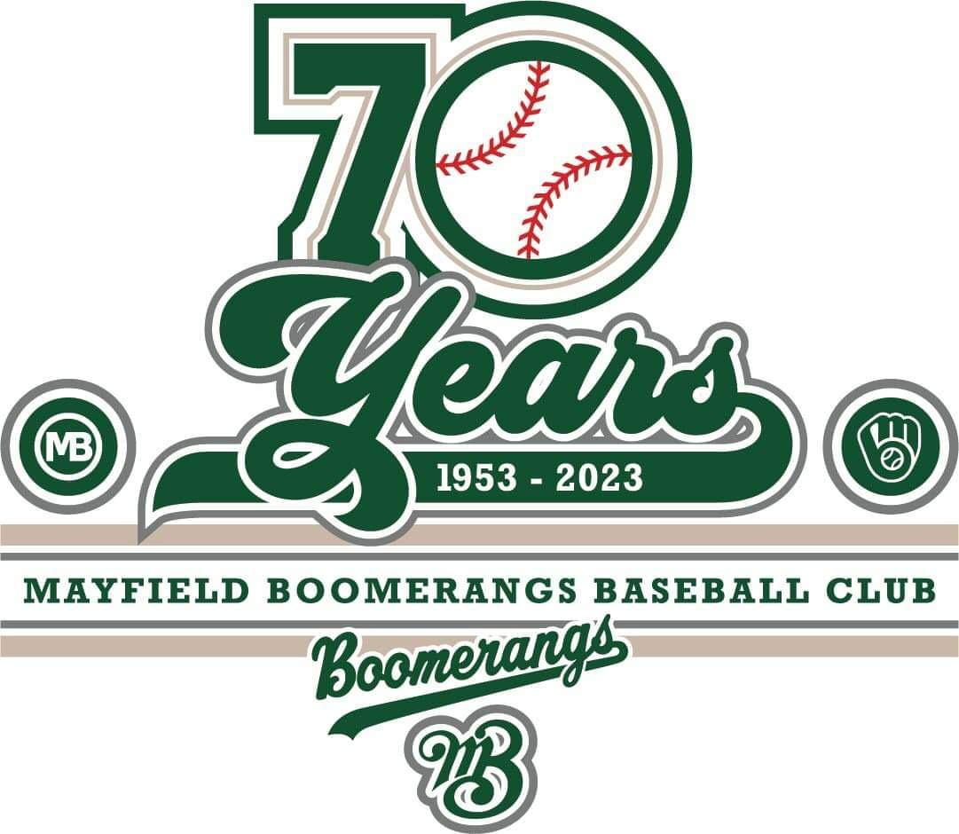
Mayfield Boomerangs Baseball Club
w: www.BoomerangsBaseball.com.au
e: MayfieldBoomerangs@Gmail.com
President: Jason Picot
Senior Vice-President: Richard Campbell
Junior Vice-President: Grant Harris
Secretary: Joshua Voigt
Treasurer: Ann Voigt
ABN: 95511551016
Incorporation Number: Y0998138

Meeting Minutes
Date | time 15/03/2023 7:00 PM | Meeting called to order by Jason Picot

Attendance
Attendees: Jason Picot (President), Richard Campbell (Snr Vice President), Grant Harris (Vice President), Joshua Voigt (Secretary), Ann Voigt (Treasurer), John Mossop, Stephen Petherbridge, Virginia Petherbridge, Matthew Reeves, Ben Reeves, Mark Sinclair, Jane Frank, Elaine Scotney, Ty Johnstone, Megan Gleeson,
Apologies: Jake Bramble, Fiona Hinton-Rogers, Kerrie Metcalfe,

Approval of Minutes
- The previous minutes for the 14/02/2023 were presented and approved.
Moved Josh, Seconded Stephen

Business Arising from Previous Minutes
- Action List – see printout
- Coaches:
  - Nick Z withdrew – Jason to give him a ring to check why.
  - Jason spoke with all the candidates.
    - Freddie is keen.
    - Jason B happy to be fill in coach for 1s if required
    - Steve H to back up Jason B in 2s if required.
    - Dan Gleeson to chase up outstanding documentation.
- Bank account ready to go just waiting for final signature – John to go to Greater Waratah.

Treasurer’s Report
Full Report attached to minutes.
MBBC Inc. Main Account | 782236229 | MBBC Inc. Canteen Account | 72138541
Opening Balance: 15/02/2023 | $466.70 | Opening Balance: 15/02/2023 | $4,410.36
Incoming: | $10,710.75 | Incoming: | $329.50
Expenses: | $2,157.75 | Expenses: | $376.09
Closing Balance: 14/03/2023 | $9,019.70 | Closing Balance: 14/03/2023 | $4,363.77
MBBC Inc. Savings Account | 721808947 | Total Balance
Opening Balance: 15/02/2023 | $22,608.67 | $33,476.34
Incoming: | $1,952.00
Expenses: | $4,467.80
Closing Balance: 14/03/2023 | $20,092.87
Junior helmets sold to players – money will be reimbursed from grass roots grant (any profit raised used to purchase other junior equipment)
Moved: Ann, Seconded: Virginia

Correspondence
- 2022 Coaches Applications – Greg & Fiona, Richard, Josh, Freddie Lewis, Nick Zulumovski
- Oz Ball Tournament Invoice
- Treasurer’s Report (14/02/23)
- Missing Active Kid Reimbursements Correspondence to BNSW
- Hunter School Sports Association – 2023 Softball Gala Days correspondence & NCC Booking
- Active Kids Voucher Redemptions (via Stephen Petherbridge)
- NBA Season Launch invitation.
- Sponsorship letter/proposal document correspondence
- NBA Advertising the Women in Sport Day.
- Registration Inquiries
- NCC Council lock on Baseball gear shed correspondence.
- Canteen Fridge Quote
- 70th Anniversary room booking correspondence.
- Hawkeye’s invoice for baseball pants.
- Registration issues
- Sponsorship opportunity – Optus Raymond Terrace
- Greater Bank account opening correspondence.
- NBA – Country Trials notification
- Treasurer’s Report (14/03/23)
Moved Josh, Seconded: Stephen

NBA Report
- NBA Season launch on Friday.
  - Need a 1st grade representative.
- Junior Coaches Meeting 14/3
  - Need all coaches accredited.
  - Final practical component available soon.
  - Junior coaches to be dressed appropriately.
  - Field preparation is important.
  - Discussed women participation and event at Speer’s Point
  - Ground availability is uncertain at this stage (Lumsden out for 2 years)
  - Pitch limits were stressed for all clubs.
  - NBA looking to put QR codes in dugouts to link to bylaws/relevant documents
  - Touched on Central Coast/NBA merger.
  - Player grading flexibility due to merger
  - NBA/Central Coast need a 12-game competition for eligibility for state/nationals (after the season)
  - Juniors start on 1st April, have 2 weeks off (Easter & School holidays) and play a couple of gala days.
- Country NSW Junior trials at Wauchope.
- NSW Country Calendar to be attached with minutes.
- Gradings due 24th March
- Softball have organised a tournament in late September, Newcastle council have spoken to the NBA and the board has elected Toronto to host the first grade grand final. (Boomerangs to host in 2024).
- Presidents meeting on the 27^{th of} March (need a club representative as Jason is on the board)

General Business
Old Action list:
- Contact Sponsors:
  - Grant & Josh – spoke with Tim Shakespeare (Rebel Chiropractic) and seems happy to return as a sponsor.
  - Beauford sponsorship final.
  - Pettigrew’s not resuming.
  - Other previous sponsors have been contacted.
  - Rich in contact with MWBC.
- Castle hill doc – Josh rebadged, all committee to review prior to weekend.
- Liquor license – Stephen Petherbridge to do asap!
- Mission/Vision Statement – Grant has draft, would like to go forward with this.
- Grant has typed up constitution (not official, just a copy)
  - Need to better understand the legal requirements and investigate whether we need insurance.
  - Will need people to research anything related to protecting the committee.
  - Jason and Grant to get together about putting together a sub committee to deal with this
  - Contacting a solicitor could be an option, suggestion of Kevin O’Brien or Tony Cavanagh (Uni)
  - Josh to put the copy onto the Webpage when complete.
Snuffy – N/A
Virginia:
- Has run off some guides for scorers who wish to learn to score in the books
- Has a collection of result sheets and additional resources.
- Thursday 30th scoring night – 7pm at MWBC
Josh:
- Mark Anderson – Junior League
- WWCC – need everyone’s in asap.
- Shirts – no funds currently available
Grant:
- Need to get agenda more priortised.
- Funds prioroitisation needs to be addressed.
- What were the next steps for the mission statement.
- Deadline for communication to the players regarding coaches.
  - Need to communicate to coaches their appointments (Jason P)
  - Then to put up on socials.
Ty – N/A
Ben:
- Finalised the gear orders.
- Looking to order a set of test helmets soon.
Matt:
- Procedures for next year, looking to have projection for next season.
- Ben to take on the full gear steward.
- Would be prepared to assist with any treasury duties.
- Elaine’s Asana software would be good to get prioritised.
Dan – N/A
Megan – N/A
Ann:
- Snuffy active kids, need to update admin rights with Service NSW
- Wanted to know if player gradings to be done in Gameday or via the NBA portal.
- Glencore grants are open if we have anyone to work on those things.
- Grass roots grant to come out from BNSW shortly.
- Registration numbers is around 70 players.
- Need to have someone to take control of TeamApp for Juniors/players – Jane offered to assist with setting things up.
Jane – N/A
Elaine – N/A
Richard:
- Ground maintenance assistance important going forward.
John:
- Wishes to make sure everyone is not too critical of everything and appreciative of everyone’s efforts.
- 70th Anniversary dinner meeting next Monday
- Need registrations in (should be better now coaches are essentially appointed)
Mark:
- Have we expressed to NDSA that we are upset with the actions to host a championship on our Grand Final weekend.
  - Josh to organise a meeting with the NDSA about the decision to host the
Jason:
- Is prepared to take phone calls from anyone regarding any conflicts.
- Need everyone to reach out to previous players to be registered asap.
- Wishes to have a scrimmage game/uniform day on the 26th of March.
- Kit bags will be signed out to each coach with inventory of equipment.
- Would be looking to have a special meeting on the 28th of March.
- First Wednesday on the 12th of April.

Next Meeting
28/03/2022 @ 7:00 pm @ Mayfield West Bowling Club
Motion to adjourn was made at 9:07 pm and was passed unanimously.

Action List
Task | Who | Due Date
Apply for the Liquor Licence | Stephen Petherbridge | ASAP
Email the NDSA to ask for a meeting | Joshua Voigt | ASAP

